**Guidelines for Oral Presentation at CTRG 2023**

* Each author for the technical paper will be given 12 minutes for the presentation followed by 3 minutes for questions and answers. Prepare the presentation to fit the time frame and practice beforehand so that you do not run out of time.
* All of the CTRG session rooms will be equipped with a projector, screen, laptop computer, and microphones.
* The slides should not be complex or overcrowded. For a 12-minute presentation, 12-15 slides may be adequate.
* Use standard fonts (such as New Times Roman, Arial, etc.) for preparing your presentation with suitable font size, color, and contrast to make it readable from the back of the room.
* Keep your presentation file name as your full paper ID used in easy-chair (paperID.pptx, like 444.pptx).
* To avoid any inconvenience, please reach to the respective venue at least 15 minutes before the start of the technical session to upload your presentation. Carry your presentation in a “USB Flash Drive” in .ppt and .pptx. Volunteers will be available to provide the necessary help in uploading your presentation.

**Guidelines for poster presentation at CTRG 2023**

 Each presenter will be assigned a board (with the paper ID mentioned at the top) to place a poster of A0 size (1189*841mm) (46.8*33.1inches).

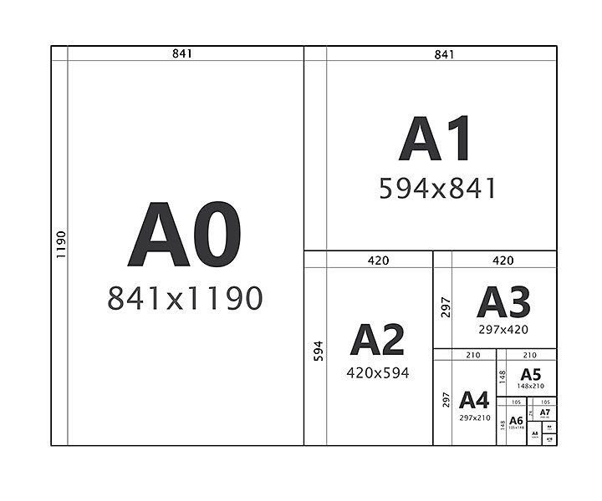

* The top portion of the poster should contain the heading ‘7th Conference of TRG’ with a font size of 80pt. The next lines in the top portion should contain the title of the paper in font size 86pt and bold, authors’ names with a font size no smaller than 60pt bold, and their affiliations with a font size no smaller than 40pt bold.  It is desirable to keep all fonts as Arial or Times New Roman.
* All main headings must not be smaller than 48pt bold. Font sizes in sub-headings must not be smaller than 40pt bold. Font sizes in the main text must be no smaller than 30pt. Font size in figure and table titles should be no smaller than 32pt.
* All letters must be easily readable from a distance of 1.5m.
* Keep your statements concise and legible in your poster. You may use about 20% text, 40% graphics, and 40% white space on your poster for an effective presentation.
* You should print your poster in advance and bring it to the venue. On-site printing service is NOT available. Please remember that the posters will be displayed in a public space. Thus, you are responsible for the security of your belongings.
* Posters can be fixed using double-sided tape/ board pins. We will provide tapes/ pins for mounting. You will be responsible for promptly removing all material at the end of the session, otherwise, those will be trashed; please leave your area in good condition for the next presenter.